

**Faculty of engineering - Shoubra Benha University**

**Name:احمد باسم مختار السيد**

**B.N: 42**

**Date: 6/4/2021**

**Topic: Programing Languages**

**Application:**  is a branch of [computer science](https://en.wikipedia.org/wiki/Computer_science) that deals with the design, implementation, analysis, characterization, and classification of [programming languages](https://en.wikipedia.org/wiki/Programming_language) and of their individual [features](https://en.wikipedia.org/wiki/Programming_language#Elements). It falls within the discipline of computer science, both depending on and affecting [mathematics](https://en.wikipedia.org/wiki/Mathematics), [software engineering](https://en.wikipedia.org/wiki/Software_engineering), [linguistics](https://en.wikipedia.org/wiki/Linguistics) and even [cognitive science](https://en.wikipedia.org/wiki/Cognitive_science). It has become a well-recognized branch of computer science, and an active research area, with results published in numerous [journals](https://en.wikipedia.org/wiki/Academic_journal) dedicated to PLT, as well as in general computer science and engineering publications.

## Screenshots:

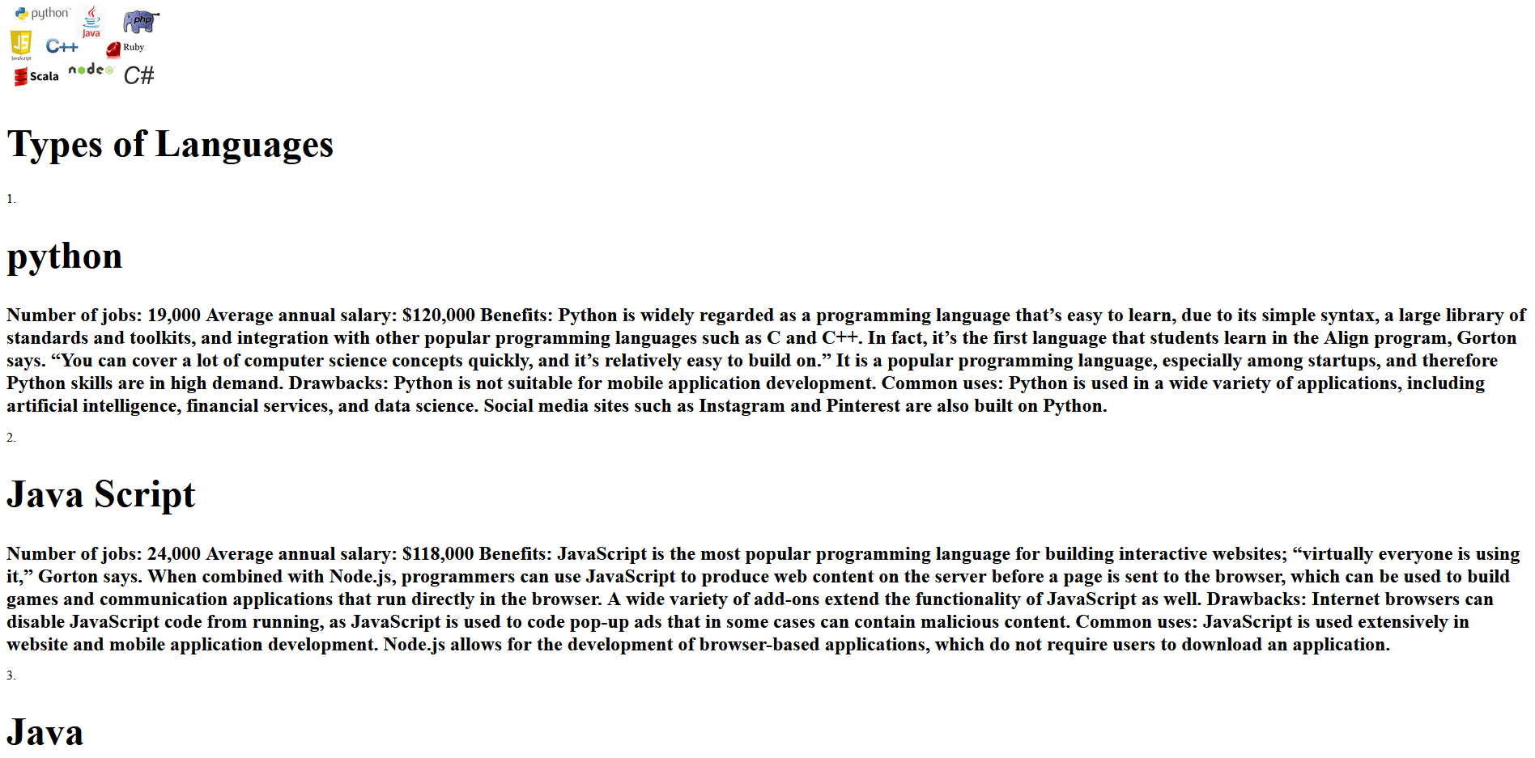

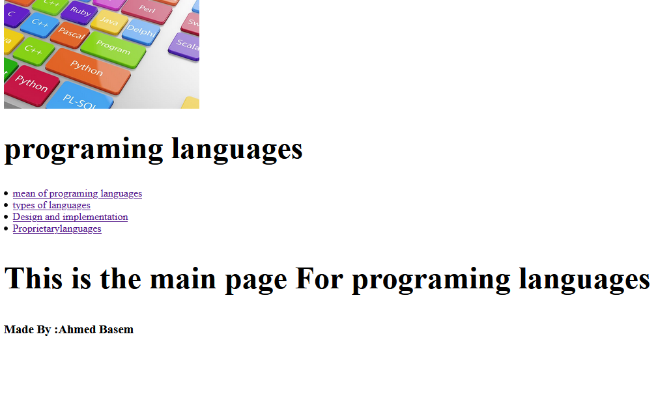

## Source Code:

